Part-2 Chapter-7

Aplia Homework: Economic Growth: Theory and Policy

**1. Effects of capital stock, technology, and human capital on labour productivity**

The following graph shows a variety of possible production functions (PFs) in an imaginary economy, assuming constant levels of technology and capital stock.

Because technology and capital stock remain unchanged, each of these production functions represents a different level of the human capital.

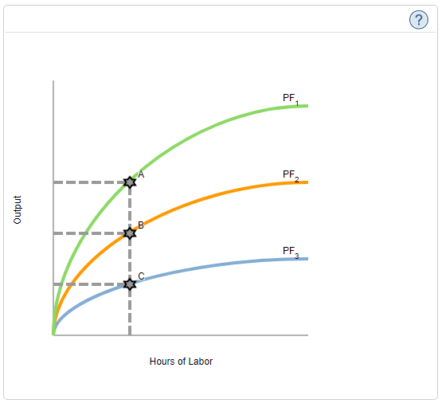

Fill in the table with the curve that corresponds to each of the human capital levels described.

| **Level of Human Capital** | **This Corresponds to Curve . . .** |
| --- | --- |
| Highest | **________** |
| Middle | **________** |
| Lowest | **________** |

The slope of the line connecting the origin to point C is _______ than the slope of the line connecting the origin to point B, because the slope of such a line is equivalent to _______.

**2. Convergence theory**

The following table shows real GDP per capita for the United States, South Korea, and Chad between 1970 and 2000. All figures are in 1998 U.S. dollars.

| **Year** | **United States** | | **South Korea** | | **Chad** | |
| --- | --- | --- | --- | --- | --- | --- |
| **Real GDP per Capita** | **Growth Rate** | **Real GDP per Capita** | **Growth Rate** | **Real GDP per Capita** | **Growth Rate** |
| **1970** | $18,395 |  | $1,886 |  | $228 |  |
| **1980** | $22,666 | 23% | $3,262 | ______ | $150 | ______ |
| **1990** | $28,435 | 25% | $6,615 | ______ | $188 | ______ |
| **2000** | $34,770 | 22% | $10,807 | ______ | $167 | ______ |

Source: Organisation for Economic Cooperation and Development (OECD)

The (decade-long) economic growth rate for the United States is shown in the second column. For example, from 1970 to 1980, the United States GDP grew from $18,395 to $22,666, an increase of $22,666−$18,395$18,395=23%.

Use this method to fill in the growth rates for South Korea and Chad in the previous table. Enter the growth rates to the nearest whole percentage point.

Compare the data for the United States and South Korea between 1970 and 1980. During this period, _______ had a higher level of real GDP per capita, while _______experienced a higher growth rate in real GDP per capita.

Convergence theory predicts that poor countries will grow more quickly than rich countries. Which one of the following is a reason for this?

Poor countries tend to have higher birth rates than rich countries.

Copying existing technologies is less expensive than developing them independently.

Rich countries devote a large fraction of their GDP to helping poor countries.

Those who don’t believe in the theory of convergence point to countries such as _______. Which of the following statements can explain why the theory of convergence may not always hold? Check all that apply.

Many poor countries have much less human capital than rich countries.

Rich countries actively try to keep poor countries poor through economic and military policies.

Many poor countries do not have the necessary infrastructure for adopting and adapting advanced technologies.

The growth experience of South Korea illustrates that relatively poor countries can ________ rich countries.

**3. Growth experiences**

Small differences in the rate of economic growth can lead to large differences in living standards. Consider two countries: Fritolaysia and Khandibar. Currently, real GDP per person (average income) is $100,000 in Fritolaysia and $25,000 in Khandibar.

Suppose you want to project what the real GDP per person will be in each country 100 years from now. The following formula shows how to compute the average income in years, where represents the growth rate of real GDP per person (in decimal form—that is, 1.4% is entered as 0.014):

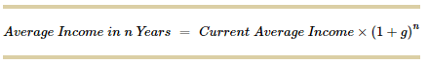

*Use the growth formula to find the correct amounts to select to fill in the following table.*

| **Growth Rate** | **Average Income after 100 Years** | |
| --- | --- | --- |
| ***(Percent)*** | ***(Dollars)*** | |
| **Fritolaysia** | **Khandibar** |
| 1.4 | **_________** | **_________** |
| 1.6 | **_________** | **_________** |
| 4 | **_________** | **_________** |
| 4.2 | **_________** | **_________** |

Suppose Fritolaysia's growth rate is expected to grow at 1.4% and remain there for the next 100 years. Which of the following growth rates in Khandibar would cause the average income in Khandibar to exceed the average income in Fritolaysia in 100 years? Check all that apply.

1.4%

1.6%

4.0%

4.2%

**4. Economic growth around the world**

The following table reports real GDP per person for several different economies in the years 1960 and 2010. It also gives each economy's average annual growth rate during this period. For example, real GDP per person in Madagascar was $1,223 in 1960, and it actually declined to $789 by 2010. Madagascar's average annual growth rate during this period was -0.87%, and it was the poorest economy in the table in the year 2010.

The real GDP-per-person figures are denominated in U.S. dollars with a base year of 2005. The following exercises will help you to understand the different growth experiences of these economies.

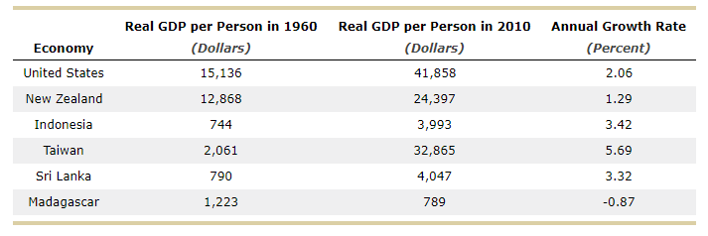

Indicate which economy satisfies each of the following statements.

| **Statement** | **Indonesia** | **Madagascar** | **New Zealand** | **Sri Lanka** | **Taiwan** | **United States** |
| --- | --- | --- | --- | --- | --- | --- |
| This economy experienced the fastest rate of growth in real GDP per person from 1960 to 2010. | ____ | ____ | ____ | ____ | ____ | ____ |  |
| This economy had the highest level of real GDP per person in the year 2010. | ____ | ____ | ____ | ____ | ____ | ____ |  |

Consider the following list of four countries. Which economy began with a level of real GDP per person in 1960 that was well below that of New Zealand and grew fast enough to catch up with and surpass New Zealand's real GDP per person by 2010?

Indonesia

Madagascar

Sri Lanka

Taiwan

**5. Economic growth and PPFs**

The blue (inner) curve on the following graph shows the current production possibilities frontier (PPF) for the economy of Wilshire, and the green (outer) curve shows the PPF for Wilshire next year if the economy were to operate at point B today. That is, investment choices today impact the growth of the economy, and thus the PPF for next year.

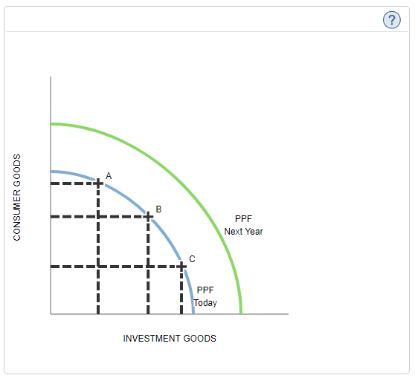

Suppose that this year, the economy is operating at point B, but then a technological advance occurs that enables greater production of either capital goods or consumer goods with the same resources. On the following graph, the PPF that best describes the Wilshire economy next year is ______________. (**Note**: The blue and green PPFs are the same as on the previous graph.)

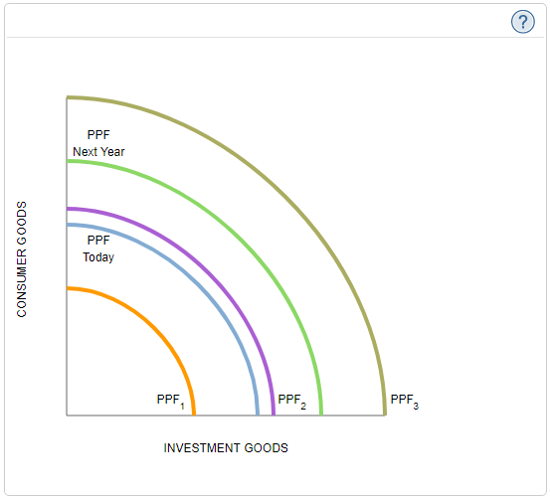

**6. Identifying innovation versus invention**

Determine whether the following scenario represents an example of invention or of innovation.

Apple releases the iPad mini, a mini version of one of the best-selling tablets.

Invention

Innovation

**7. The cost disease of the personal services**

Three main ideas help explain why the prices of some services, such as education, health care, and the performing arts, continue to rise relative to those of other goods or services. Fill in the following table by selecting the missing idea.

|  |  |
| --- | --- |
| 1. | **_________________________________________________.** |
| 2. | Real wages tend to rise at the same rate as labour productivity. |
| 3. | Productivity cannot or does not grow for certain services. |
|  |  |

Using these three ideas, indicate which of the following statements about primary care physicians and factory workers is true in accordance with the cost disease of the personal services? Check all that apply.

Wages of primary care physicians rise at a slower rate than their productivity growth.

Wages of primary care physicians will rise at a faster rate than the rate of productivity growth.

The services of primary care physicians will become relatively more expensive than those of factory workers.